After testing the new changes that were made with the Purchasing Manager, she noticed that the process is flipped.
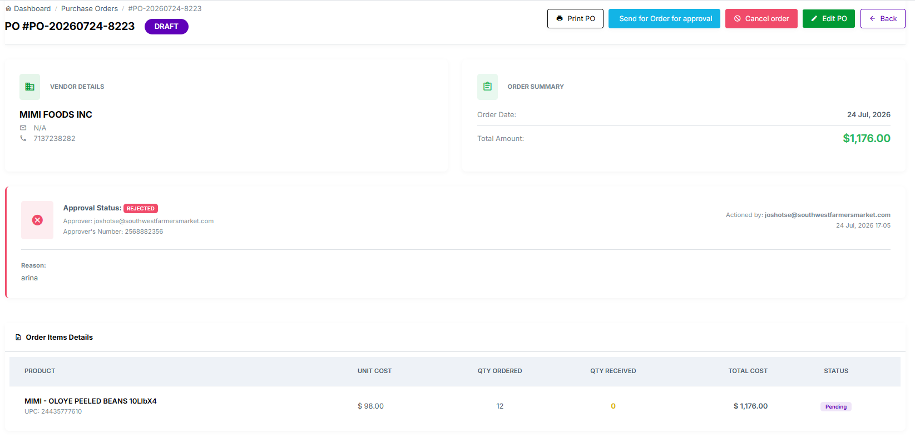
After clicking on save draft this should be the next screen that pops up, while still on draft, she can choose to: print Po - send order for approval - cancel the order - edits po.
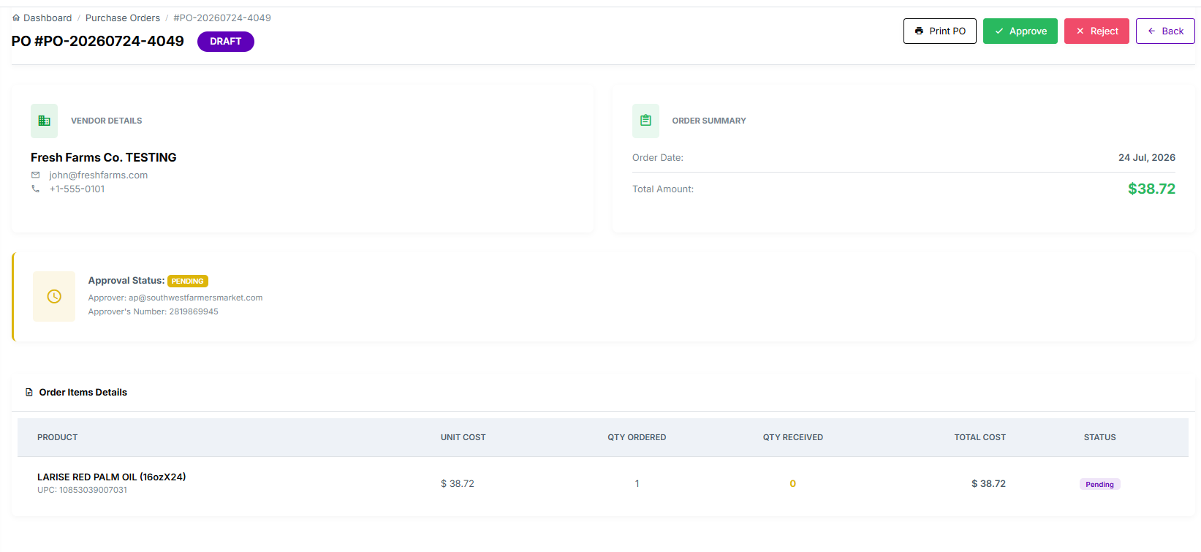
then this process: waiting for approval

After it has been approved then it goes to this screen print po, send to vendor, cancel order.
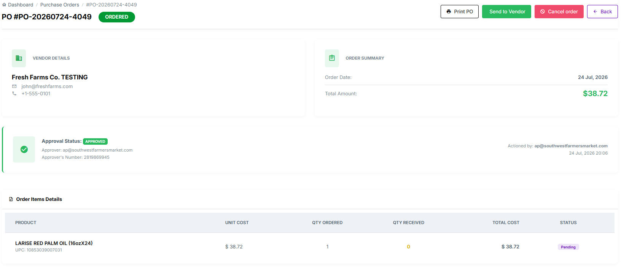

If the po was rejected it goes back to this screen.

